NAME:SYED MUHTASIM ALAM APON
SUBJECT : CSE 2102
DATA STRUCTURE AND ALGORITHM LAB

Problem 1:
Given a sorted array that may contain duplicates, find the first and last occurrence of a target element using binary search.
Source Code:
#include <bits/stdc++.h>
using namespace std;
bool binarysearch(int arr[], int n, int target)
{
int low = 0;
int high = n - 1;
int mid = low + (high - low) / 2;
while (low <= high)
{
mid = high + low / 2;
if (arr[mid] == target)
return true;
else if (arr[mid] > target)
high = mid - 1;
else
low = mid + 1;
}
return false;
}
int searchmid(int arr[], int n, int target)
{
int low = 0;
int high = n - 1;
int mid = low + (high - low) / 2;
while (low <= high)
{
mid = high + low / 2;
if (arr[mid] == target)
return mid;
else if (arr[mid] > target)
high = mid - 1;
else
low = mid + 1;
}
return 0;
}
int lowerbound(int arr[], int n, int key, int target)
{
int lowerbound = -1;
int low = 0;
int high = n - 1;
int mid = low + (high - low) / 2;
while (low <= high)
{
mid = high + low / 2;
if (arr[mid] == target)
{
lowerbound = mid;
high = mid - 1;
}
else if (arr[mid] > target)
high = mid - 1;
else
low = mid + 1;
}
return lowerbound;
}
int upperbound(int arr[], int n, int key, int target)
{
int upperbound = -1;
int low = 0;
int high = n - 1;
int mid = low + (high - low) / 2;
while (low <= high)
{
mid = high + low / 2;
if (arr[mid] == target)
{
upperbound = mid;
low = mid + 1;
}
else if (arr[mid] > target)
high = mid - 1;
else
low = mid + 1;
}
return upperbound;
}

int main()
{
int n;
cout << "Enter Size of the Array:\n";
cin >> n;
int arr[n];
cout << "Input:\n";
for (int i = 0; i < n; i++)
cin >> arr[i];
int target;
cout << "Target:\n";
cin >> target;
if (binarysearch(arr, n, target))
{
int set = searchmid(arr, n, target);
int key = arr[set];
int first = lowerbound(arr, n, key, target);
int last = upperbound(arr, n, key, target);
int occur = last - first + 1;
cout << "Output:\n";
cout << "First= " << first << ",Last= " << last << ",Count= " << occur << "\n";
}
else
{
cout << "Element not Found!!\n";
}
}
Output Screenshot:
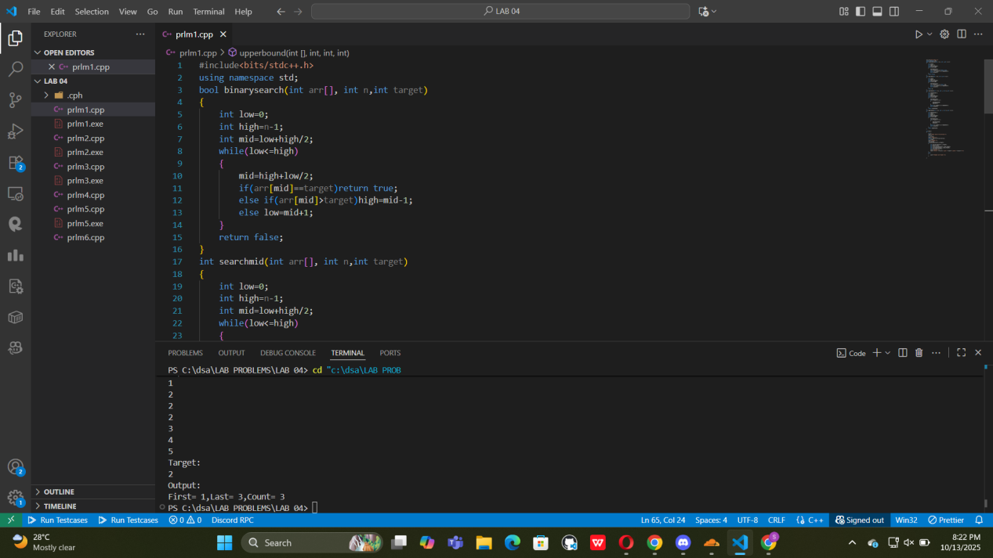

Problem 2: Factorial and Fibonacci
Implement the Recursive factorial and the Recursive Fibonacci sequence generation.

Example:
Input: n = 5
Output:
Factorial = 120
Fibonacci = 0 1 1 2 3

Source Code:
#include <bits/stdc++.h>
using namespace std;
long int factorial(long int n)
{
if (n == 0 || n == 1)
return 1;
return n * factorial(n - 1);
}
long int fibonacci(long int n)
{
if (n == 1)
return 0;
if (n == 2)
return 1;
return fibonacci(n - 1) + fibonacci(n - 2);
}
void printfibonacci(int n)
{
for (int i = 1; i <= n; i++)
{
cout << fibonacci(i) << " ";
}
cout << "\n";
}
int main()
{
printf("Input:\n");
long int n;
scanf("%lld", &n);
long int fact = factorial(n);
printf("Output:\n");
printf("Factorial=");
cout << fact << "\n";
printf("Fibonacci= ");
printfibonacci(n);
}

Output ScreenShot:

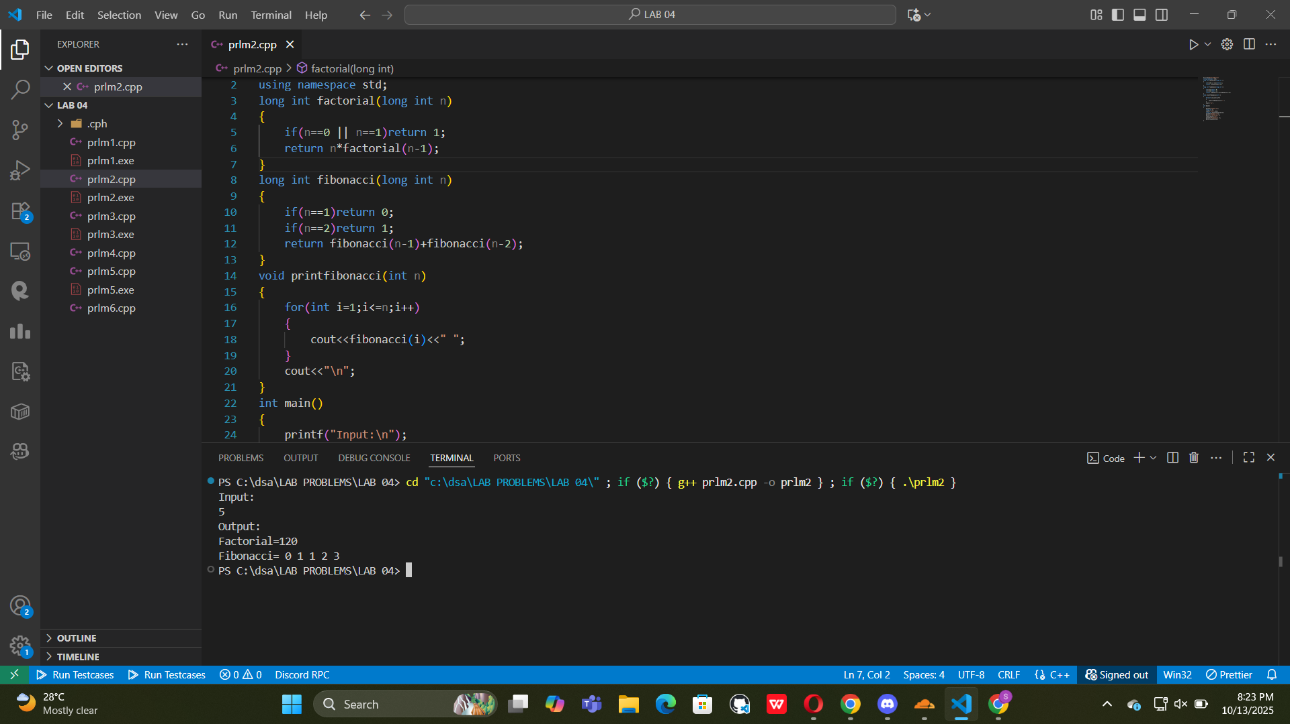
Problem 3: Recursive Sum of Array Elements
Given an array, recursively calculate the sum of its elements.

Example:
Input: [1, 2, 3, 4, 5]
Output: 15

Source Code:

#include <bits/stdc++.h>
using namespace std;
long int sum(long int arr[], int n)
{

if (n == 0)
return 0;
return arr[n - 1] + sum(arr, n - 1);
}

int main()
{
long int n;
cout << "Enter Size of Array:\n";
cin >> n;
printf("Input:\n");
long int array[n];
for (int i = 0; i < n; i++)
cin >> array[i];
long int s = sum(array, n);
printf("Output:\n");
cout << s << "\n";
}

Output ScreenShot:

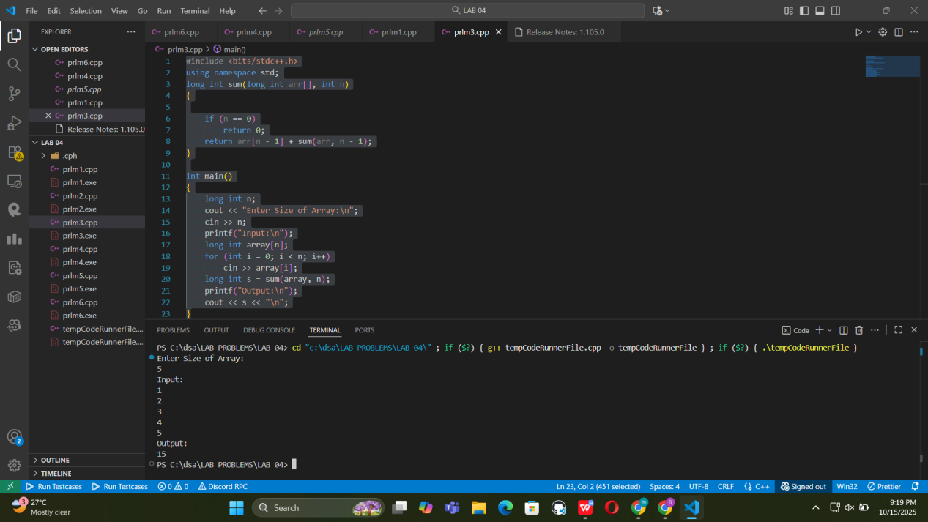
Problem 4: Recursive Merge of Two Sorted Arrays
Write a recursive function to merge two sorted arrays into one sorted array.
No loops allowed.

Example:
Input:

A = [1, 4, 7]
B = [2, 3, 5, 6]

Output: [1, 2, 3, 4, 5, 6, 7]

Source Code:

#include<bits/stdc++.h>
using namespace std;
vector<long long>mergealgo(vector<long long>A,int i,vector<long long>&B,int j)
{
if(i >= A.size()) return vector<long long>(B.begin() + j, B.end());
if (j >= B.size()) return vector<long long>(A.begin() + i, A.end());
if(A[i]<=B[j])
{
vector<long long>merged=mergealgo(A,i+1,B,j);
merged.insert(merged.begin(),A[i]);
return merged;
}
else
{
vector<long long>merged=mergealgo(A,i,B,j+1);
merged.insert(merged.begin(),B[j]);
return merged;
}
}
int main()
{
cout<<"Enter size of First Array:\n";
int n,m;
cin>>n;
vector<long long>A(n);
for(int i=0;i<n;i++)cin>>A[i];
cout<<"\n";
cout<<"Enter size of Second Array:\n";
cin>>m;
vector<long long>B(m);
for(int i=0;i<m;i++)cin>>B[i];
cout<<"\n";
cout<<"Merged Array:\n";
vector<long long>mergedarray=mergealgo(A,0,B,0);
for(int i=0;i<mergedarray.size();i++)
{
cout<<mergedarray[i]<<" ";
}
cout<<"\n";

}

Output ScreenShot:

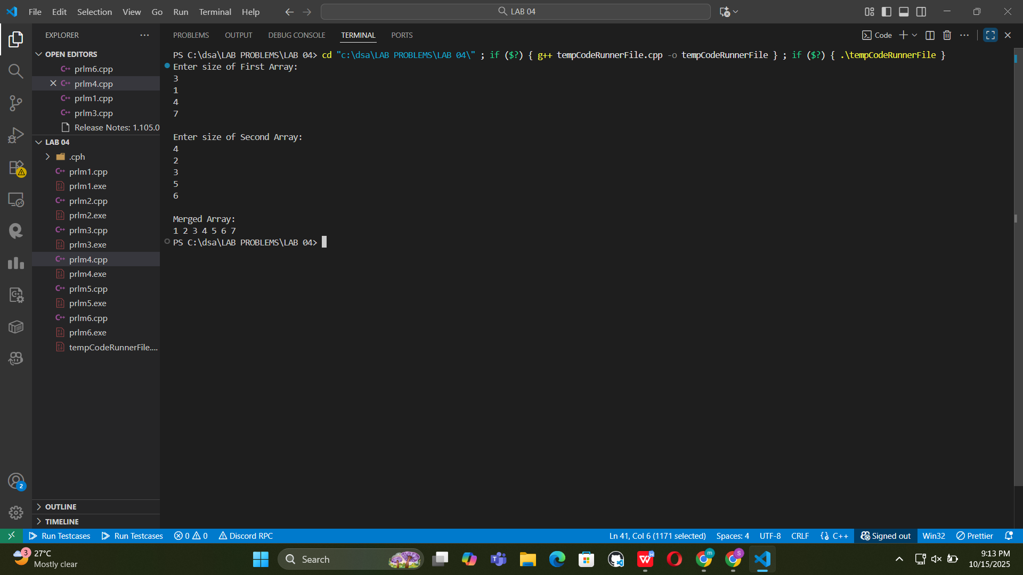
Problem 5: Quicksort
Implement the Quicksort algorithm, considering the first index as the pivot.

Source Code:

#include <bits/stdc++.h>
using namespace std;
int partition(int arr[], int low, int high)
{
int pivot = arr[low];
int i = low + 1;
int j = high;
while (true)
{
while (i <= high && arr[i] <= pivot)
i++;
while (j >= low && arr[j] > pivot)
j--;
if (i >= j)
break;
swap(arr[i], arr[j]);
}
swap(arr[low], arr[j]);
return j;
}
void quicksort(int arr[], int low, int high)
{
if (low < high)
{
int p = partition(arr, low, high);
quicksort(arr, low, p - 1);
quicksort(arr, p + 1, high);
}
}
int main()
{
int n;
cout << "Size of the array:\n";
cin >> n;
int arr[n];
cout<<"Array Elements:\n";
for (int i = 0; i < n; i++)
cin >> arr[i];
quicksort(arr, 0, n - 1);
cout << "Sorted Array:\n";
for (int i = 0; i < n; i++)
cout << arr[i] << " ";
cout << "\n";
}

Output ScreenShot:

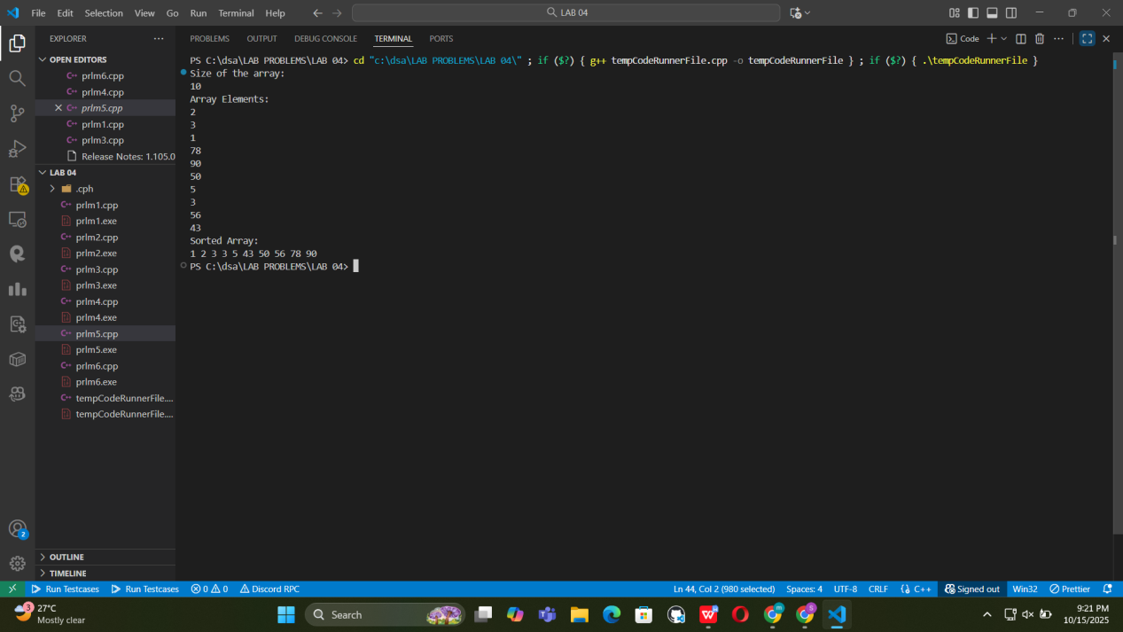
Problem 6: Compare Sorting Algorithms

Task:
Implement the following sorting algorithms:

Bubble Sort
Insertion Sort
Selection Sort
Merge Sort
Quick Sort

Input: Random array of integers.
Output: Sorted array and number of comparisons/swaps for each algorithm.

Goal: Compare their performance on arrays of size 10, 100, and 1000.

Source Code:
#include <bits/stdc++.h>
using namespace std;
long long comparisons = 0;
long long swaps = 0;
void reset()
{
comparisons = 0;
swaps = 0;
}
vector<long long> arr(long long n, int min = 0, int max = 10000)
{
random_device rd;
mt19937 gen(rd());
uniform_int_distribution<> dist(min, max);
vector<long long> arr(n);
for (int i = 0; i < n; i++)
arr[i] = dist(gen);
return arr;
}
int partition(vector<long long> &arr, int low, int high)
{
int pivot = arr[low];
int i = low + 1;
int j = high;
while (true)
{
while (i <= high && arr[i] <= pivot)
{
comparisons++;
i++;
}
while (j >= low && arr[j] > pivot)
{
comparisons++;
j--;
}
if (i >= j)
break;
swap(arr[i], arr[j]);
swaps++;
}
swap(arr[low], arr[j]);
swaps++;
return j;
}
void quicksortalgo(vector<long long> &arr, int low, int high)
{
if (low < high)
{
int p = partition(arr, low, high);
quicksortalgo(arr, low, p - 1);
quicksortalgo(arr, p + 1, high);
}
}
void quicksort(vector<long long> &arr)
{
quicksortalgo(arr, 0, arr.size() - 1);
}
void bubblesort(vector<long long> &arr)
{
int n = arr.size();
for (int i = 0; i < n - 1; i++)
{
for (int j = 0; j < n - i - 1; j++)
{
comparisons++;
if (arr[j] > arr[j + 1])
{
swap(arr[j], arr[j + 1]);
swaps++;
}
}
}
}
void selectionsort(vector<long long> &arr)
{
int n = arr.size();
for (int i = 0; i < n - 1; i++)
{
int index = i;
for (int j = i + 1; j < n; j++)
{
comparisons++;
if (arr[j] < arr[index])
{
index = j;
}
}
if (index != i)
{
swap(arr[i], arr[index]);
swaps++;
}
}
}
void merge(vector<long long> &arr, int l, int m, int r)
{
int l1 = m - l + 1;
int l2 = r - m;
vector<long long> L(l1), R(l2);
for (int i = 0; i < l1; i++)
L[i] = arr[l + i];
for (int i = 0; i < l2; i++)
R[i] = arr[m + 1 + i];
int i = 0, j = 0, k = l;
while (i < l1 && j < l2)
{
comparisons++;
if (L[i] <= R[j])
arr[k++] = L[i++];
else
arr[k++] = R[j++];
swaps++;
}
while (i < l1)
{
arr[k++] = L[i++];
swaps++;
}
while (j < l2)
{
arr[k++] = R[j++];
swaps++;
}
}
void mergesortalgo(vector<long long> &arr, int l, int r)
{
if (l < r)
{
int m = l + (r - l) / 2;
mergesortalgo(arr, l, m);
mergesortalgo(arr, m + 1, r);
merge(arr, l, m, r);
}
}
void mergesort(vector<long long> &arr)
{
mergesortalgo(arr, 0, arr.size() - 1);
}
void insertionsort(vector<long long> &arr)
{
int n = arr.size();
for (int i = 1; i < n; i++)
{
int target = arr[i];
int j = i - 1;
while (j >= 0 && (++comparisons && arr[j] > target))
{
arr[j + 1] = arr[j];
swaps++;
j--;
}
arr[j + 1] = target;
}
}
void print(string technique, long long n, long long comparisons, long long swaps)
{
cout << setw(15) << left << technique << "| Comparisons: " << setw(10) << comparisons << "Swaps: " << swaps << "\n";
}
int main()
{
vector<long long> size = {10, 100, 1000};
for (int n : size)
{
cout << "\n Array Size: " << n << " \n";
vector<long long> randomarr = arr(n);
cout << "Sorted array: ";
vector<long long> temp = randomarr;
bubblesort(temp);
for (int i = 0; i < n; i++)
cout << temp[i] << " ";
cout << "\n";
vector<long long> arr1 = randomarr;
reset();
bubblesort(arr1);
print("Bubble Sort", n, comparisons, swaps);
vector<long long> arr2 = randomarr;
reset();
insertionsort(arr2);
print("Insertion Sort", n, comparisons, swaps);
vector<long long> arr3 = randomarr;
reset();
selectionsort(arr3);
print("Selection Sort", n, comparisons, swaps);
vector<long long> arr4 = randomarr;
reset();
mergesort(arr4);
print("Merge Sort", n, comparisons, swaps);
vector<long long> arr5 = randomarr;
reset();
quicksort(arr5);
print("Quick Sort", n, comparisons, swaps);
}
}

Output ScreenShot:
